صورة تحتوي على توضيح, رسوم متحركة, قصاصة فنية, التصميم

تم إنشاء الوصف تلقائياً بثقة متوسطةصورة تحتوي على دائرة, رسوم متحركة

تم إنشاء الوصف تلقائياً

Name: Shady Mohamed Abdel Gawad

ID: 20200246

Subject: Topics in Information Technology-2 (Cloud Computing)‬‏

Under the supervision of: Dr/ Nour Mahmoud

Group: S1

**Part 1 - Investigate vCenter Server:**

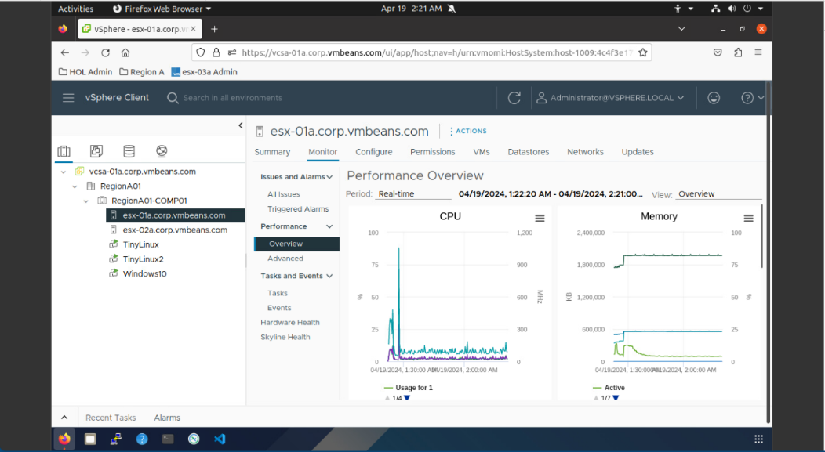

**performance of one of ESXi server**

* 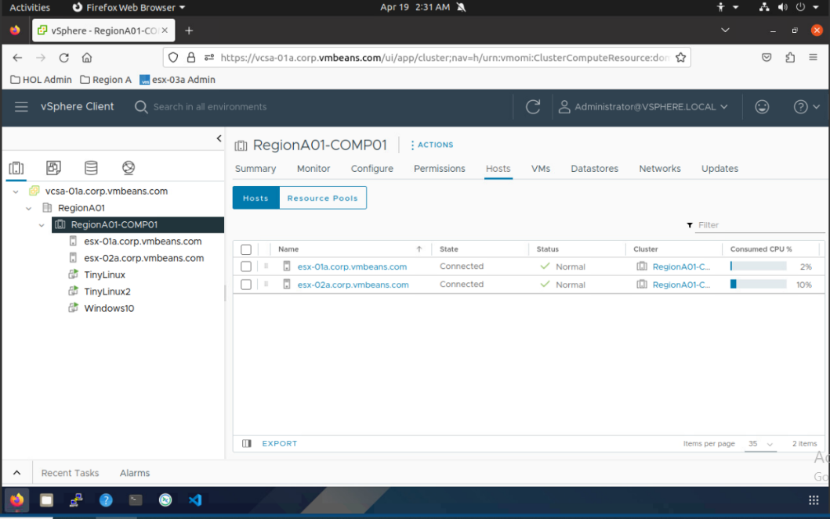**How many networks in this datacenter object? 6 Networks**

**RegionA01-comp01 cluster view**

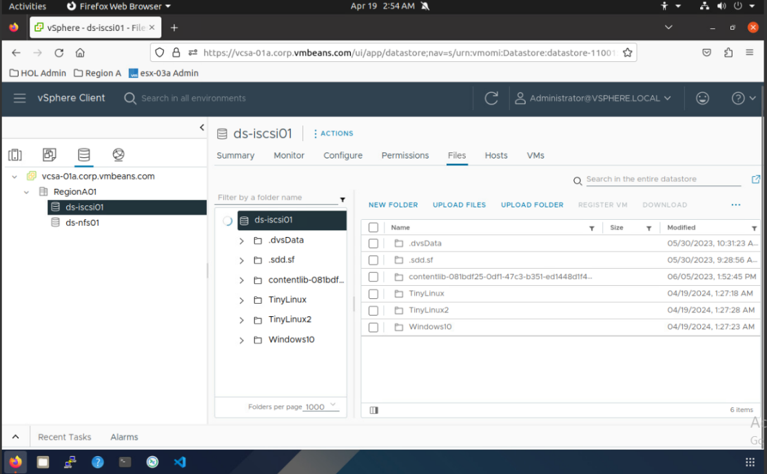

صورة تحتوي على نص, برمجيات, أيقونة الحاسوب, صفحة ويب

تم إنشاء الوصف تلقائياً

**Networking**

**Datastores**

**Part2-Virtual networking:**

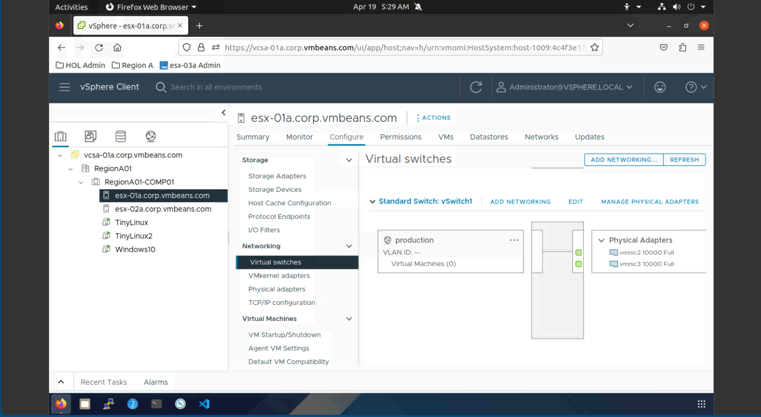

**Add another physical interface.**

**Production port group**

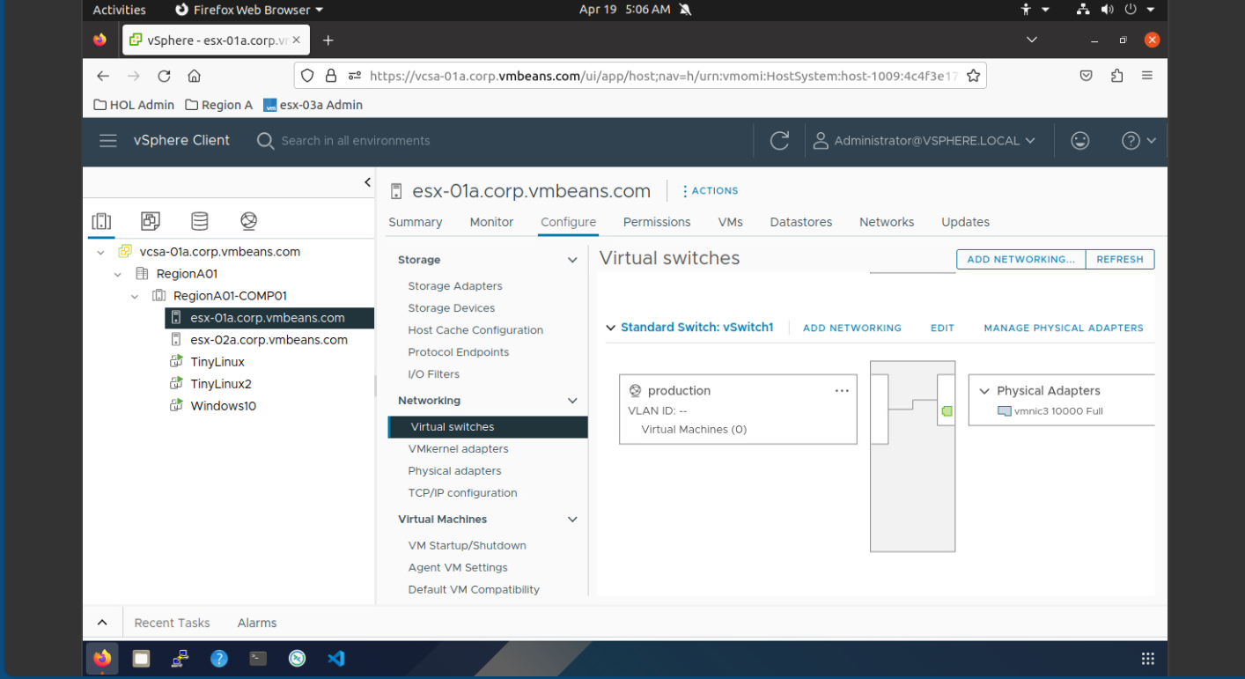

**all security policy settings are accepted.**

صورة تحتوي على نص, لقطة شاشة, برمجيات, أيقونة الحاسوب

تم إنشاء الوصف تلقائياً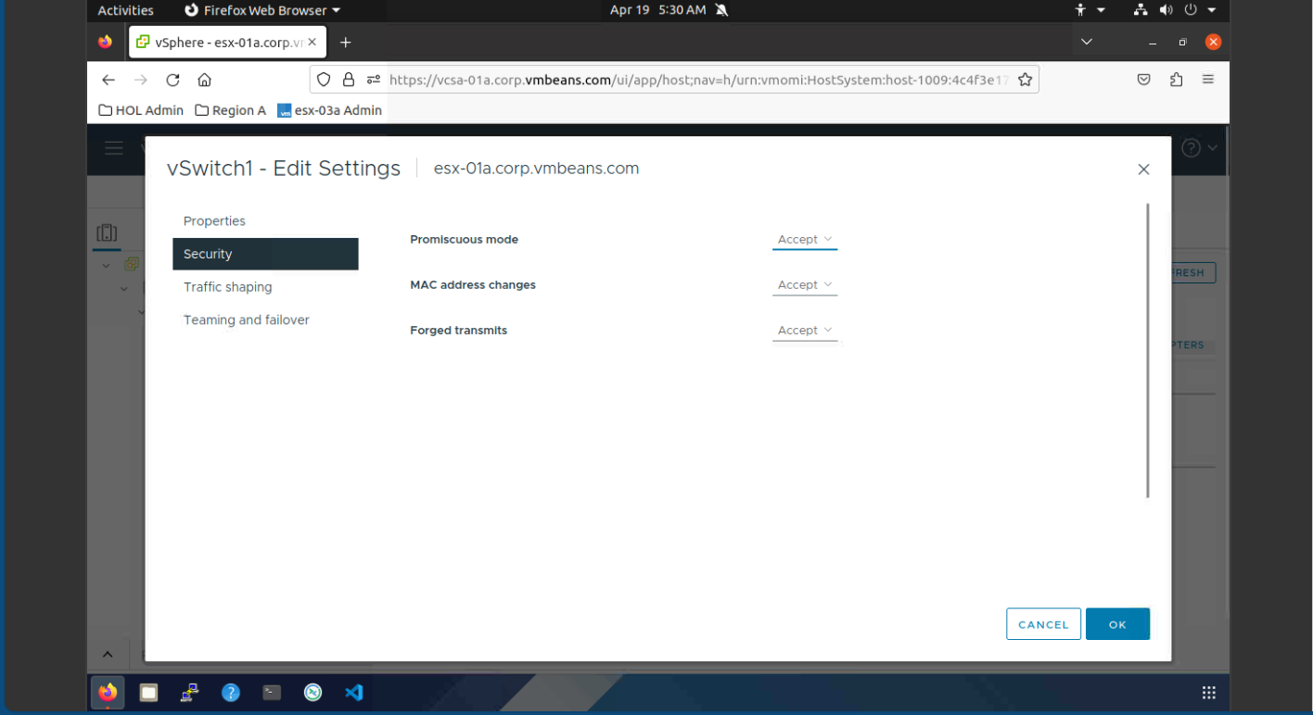

**failover order.**

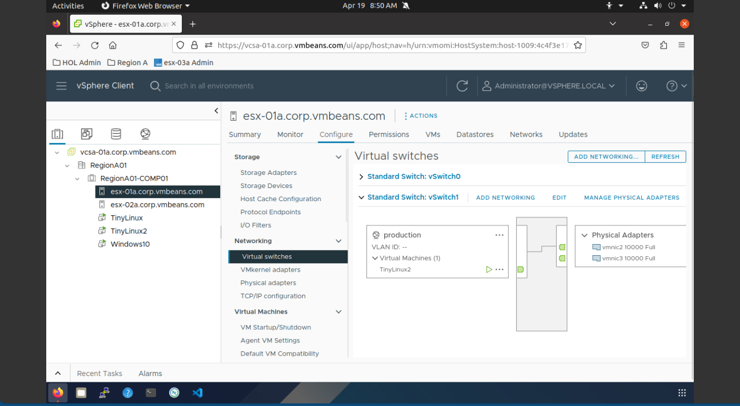

**VM added to standard switch.**

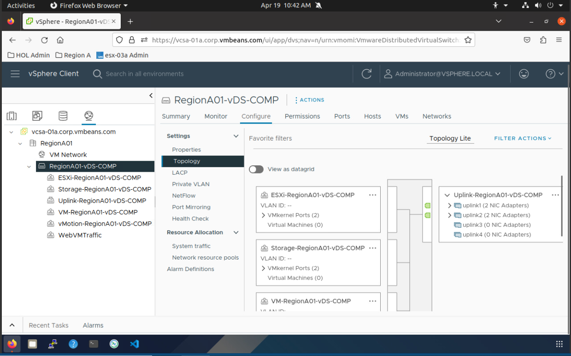

**Distributed switch part.**

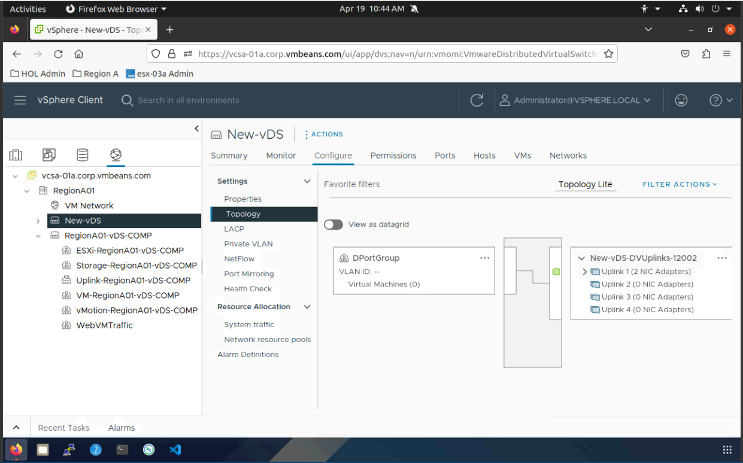

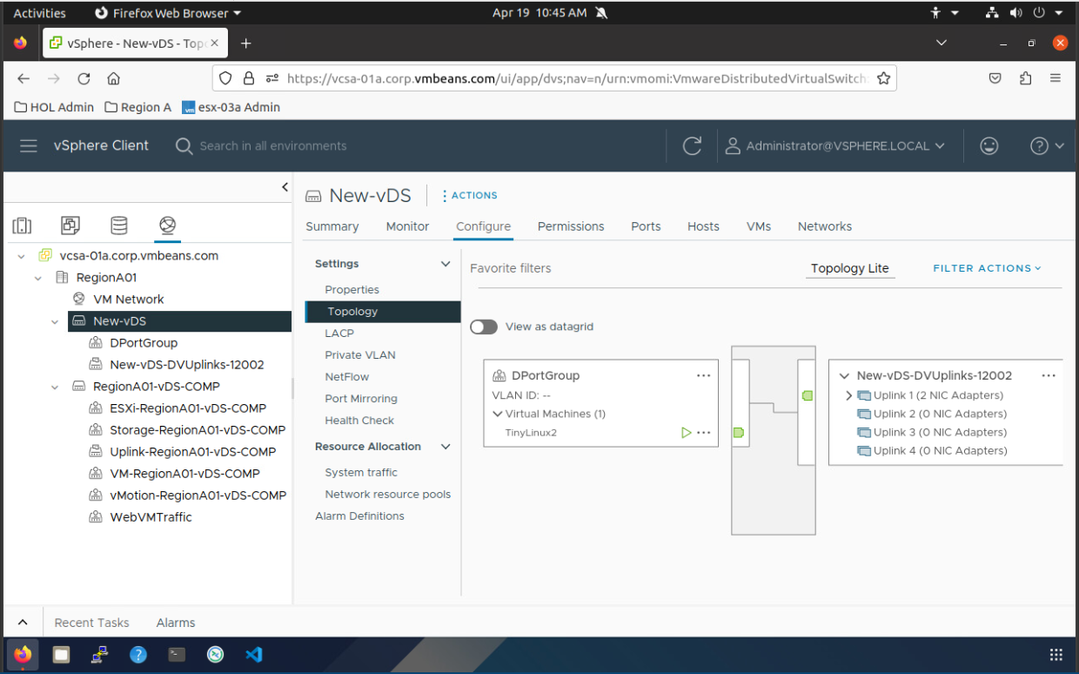

* **What is the difference between standard and distributed virtual switches?**
* **Both standard and distributed virtual switches are used in cloud computing environments, but they differ in their scope and management:**
* **Standard Virtual Switch (vSS):**

**Scope: Limited to a single ESXi host. Each VM on that host connects to the network through the standard vSwitch.**

**Management: Configured and managed individually on each ESXi host. This can be cumbersome for large deployments.**

**Use case: Ideal for simple setups with a small number of VMs on a single host.**

* **Distributed Virtual Switch (vDS):**

**Scope: Spans across a cluster of ESXi hosts. Multiple VMs on different hosts can connect to the same vDS.**

**Management: Centrally managed through vCenter Server. This simplifies configuration and ensures consistency across the cluster.**

**Features: Offers additional features like:**

**Network vMotion: Allows seamless migration of VMs between hosts without disrupting network connectivity.**

**Traffic shaping: Enables prioritizing network traffic for specific VMs.**

**Centralized security policies: Security settings can be applied consistently across all VMs connected to the vDS.**

**Use case: Perfect for complex cloud environments with multiple VMs spread across a cluster of ESXi hosts.**

* **Here's an analogy:**

**Standard vSwitch: Think of it as a local switch in a building. It connects devices within that specific location.**

**Distributed vDS: Imagine it as a central network switch for an entire campus. It connects devices across multiple buildings.**

* **In summary, standard vSwitches are suitable for basic setups, while distributed vDSs offer greater scalability, centralized management, and advanced features for managing network traffic in complex cloud environments.**